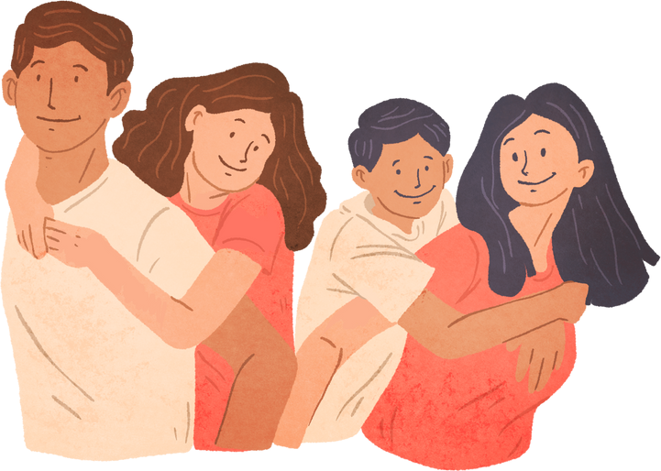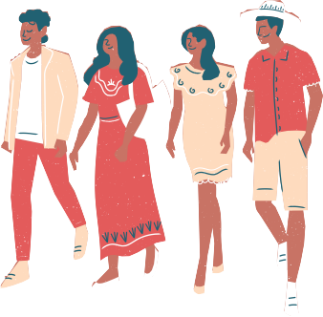

CONGENITAL HEART DISEASE TRANSITION RESOURCE VIDEO

Have you transitioned from pediatric to adult care?
Want to share your experience with others?

W E A R E L O O K I N G F O R V O L U N T E E R S T O T A K E P A R T I N A C H D T R A N S I T I O N R E S O U R C E V I D E O

VIDEO INFORMATION
Transition is the process of moving young adults with medical conditions from pediatric to adult-oriented care We are looking for participants and family members, aged 18 years or older, to share their transition experience Participants will share their experience of transitioning from pediatric to adult CHD care and answer a few commonly asked questions about the process
Responses can either be recorded in a 30-second video or written through a secure form
Recordings and post submissions will be compiled into a resource video for patients and families

Please scan the QR code below if you are interested in participating.
If you have questions or need more information, contact info@cchaforlife.org

