Questions and Answers from Fontan Education Day

April 24, 2022

Will the materials from the Fontan Education Day be available for individuals who were not able to attend?

Yes, the materials are posted on the Canadian Fontan website https://canadianfontan.com/blog/fontan-education-day/ and are publically available.

Is there a list of cardiologists in Canada who specialize in caring for adult patients living with a single ventricle/Fontan operation?

On the Canadian Fontan website, there is a map of Canadian centres (both pediatric and adult) that provide cardiology care for individuals after the Fontan operation https://canadianfontan.com/find-an-expert/
Below is an example of clicking on the Vancouver location:

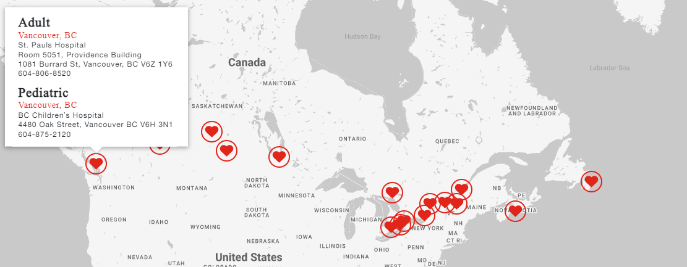

What types of physical exercises are safe for Fontan patients?

Meeting the guidelines for daily activity is important in maintaining and preserving your health. Some movement is better than none and adding various intensity levels – physical activity, muscle strengthening, stretching and standing all contribute towards a healthy day. Moderate level exercises that would benefit individuals with a Fontan include:
- Walking
- Biking
- Swimming and other water activities (water walking, aqua fitness)
If you have an activity you’d like to try and are uncertain about participating, please check with your cardiac care provider who will be able to advise further.

Other than the lifestyle choices already talked about, is there anything we can do to improve our fitness ability?

There are individual’s with a Fontan circulation who have above average levels of fitness, including running marathons. As long as you are feeling well and have not been told to restrict your activity – you ought to be able to pursue activities to improve your fitness level. If you are not confident on how to proceed with exercising, please consult with your cardiac team.

Are the components of marijuana (CBD and THC) also bad for your health?

Cannabis (marijuana) contains hundreds of chemical substances, over 100 of these are know as cannabinoids. Cannabinoids have effects on receptors in the brain and body. The 2 most researched cannabinoids are delta-9-tetrahydrocannabinol (THC) and Cannabidiol (CBD).

THC is responsible for the way your brain and body respond to cannabis – the high and intoxication.

CBD does not produce a high and there is some evidence that CBD may lower some of the effects of THC on the brain. CBD is being studied for possible therapeutic uses.

Cannabis use has many potential adverse health effects – we recommend that you carefully consider the health effects, especially for your heart and your brain. Additional information can be found on the Government of Canada website:
https://www.canada.ca/en/health-canada/services/drugs-medication/cannabis/health-effects/effects.html

Pregnancy considerations for individuals who have had a Fontan surgery?

Women who have had a Fontan procedure may be able to have a successful pregnancy and delivery under the care of a team that manages pregnancy in women with heart conditions. There are risks to both the mother and the baby (including miscarriage and preterm labour) and we recommend that you have a consultation prior to becoming pregnant to understand these risks and how to best manage them. Please request your cardiologist make arrangements for you to discuss your personal risks and how to best plan for pregnancy

A good overview of pregnancy with congenital heart disease can be found at:
https://www.achaheart.org/media/3448/qapregnancy.pdf

And please remember that as you wait for a good time to have a family, women with Fontan circulations are at increased risk of blood clots and should only use progesterone based contraceptives. You can find a good birth control recommendation here:
https://www.achaheart.org/media/3450/qandabirthcontrol2022.pdf

What are some complications that may occur during pregnancy?

Some issues that may occur in pregnancy include:
- Heart function/failure issues, heart valve problems, and heart rhythm (arrhythmias) problems
- Blood clots (also called thromboembolism)
- Miscarriage or premature labour and delivery

Women with Fontan circulations frequently deliver babies prematurely and their babies are small for the gestational age.

If you are pregnant, what is the likelihood your child will have CHD?

The risk of having a baby with a congenital heart condition is higher than in the general population. This is true regardless of which parent has a Fontan circulation. This is something that you will want to consider and discuss with your cardiac team.

The risk of a parent passing on a congenital heart condition is ~ 3 – 5 % versus approximately 1% in the general population.

Are you collecting data on women that want to have children or are pregnant with a single ventricle?

Yes, if you have been pregnant and have a Fontan circulation – your data has likely been used in research studies on Fontan and pregnancy outcomes (if you agreed to have your data included in the research data base)

Are there studies of different types of Fontan for pregnancy?

There are studies looking at pregnancy outcomes in the Fontan population, but not necessarily looking at outcomes by Fontan type.

Are there any issues with males with a Fontan circulation trying to conceive?

There is limited data on this topic and currently there is no evidence that the Fontan circulation has an impact on the male ability to conceive children.

How are difficulties in fertility diagnosed?

Fertility challenges are diagnosed by reproductive medicine specialists. These specialists are also available to advise and treat some conditions that cause infertility.

Please request that your reproductive medicine specialist work closely with your cardiac team for your care. Often, you will need your medications adjusted with the administration of hormones and surgical procedures. You may also require anticoagulation (blood thinners) adjusted or stopped for fertility treatments.

Is surrogacy a potential option for Fontan patients trying to get pregnant?

Surrogacy is a potential option for individuals with a Fontan circulation wishing to start a family. This is usually organized by a fertility clinic plus legal advice to arrange the contract.

Is there specific mental health support for Fontan patients that are trying to start families?...Someone to help through the transition into pregnancy?

Mental health support may be available through cardiac obstetric programs and it is best to enquire about this through the program in your province.

Is there a Fontan registry in the US?

While the Canadian Fontan registry is a relatively new initiatives, there are registries in the US, the UK and Australia New Zealand. These registries are important in understanding the outcomes following a Fontan surgery and will assist with improving the care of an individual who has a Fontan circulation.

Do most Fontan patients apply for Persons with disabilities?

Some individuals who have a Fontan circulation may qualify for persons with disabilities benefits, many individuals continue to work and/or go to school. Benefit requirements are determined at a provincial level and we recommend that you inquire about benefit qualifications in your province.

Is there a list of resources specifically for CHD patients for accessing specific therapy/services that are familiar with condition?

Not that we are aware of. Your cardiac care providers may be able to link you with services that they recommend for individuals with congenital heart disease.

What is the percentage of patients who have had a Fontan operation who need a second Fontan operation? and what causes that?

The original Fontan operation connected the right atrium to the pulmonary artery, this is called a ‘Classic’ or ‘Right Atrium to Pulmonary Artery’ Fontan. This type of Fontan operation was done until some time in the 1980’s (depending on the surgical centre). The issue with this type of Fontan operation is that people develop arrhythmia, heart failure, blood clots and other symptoms of Fontan Failure.

Later versions of the Fontan surgery proved to have better outcomes and is the preferred surgery for individuals with a single ventricle. Patients with a ‘Classic Fontan’ may benefit from having their Fontan upgraded to an extracardiac Fontan to improve their heart’s function. A small number of patients will require a second Fontan surgery.

Fontan conversion:
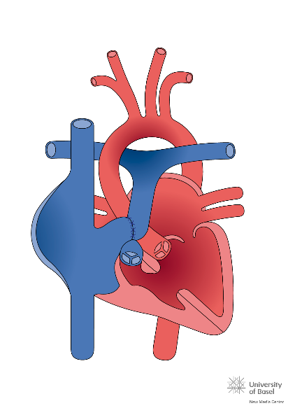 |  |  | 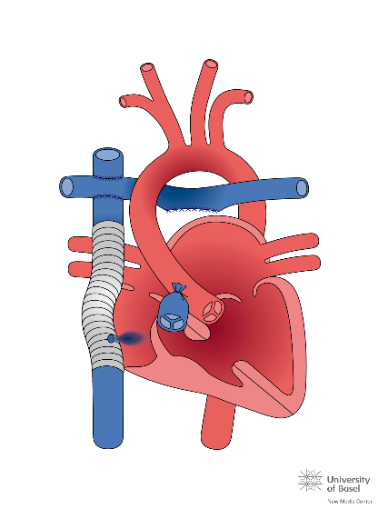
Classic Fontan |  |  | Extracardiac Fontan with Fenestration
Is it recommended to close a fenestration if stable and saturations are around 90-92% or is it best to wait until there is an issue?
Part of the Fontan operation involves making a tunnel to bring oxygen-poor blood directly from the body into the lungs. The tunnel connects the inferior vena cava to the pulmonary artery, bypassing the heart. It can be made in one of two ways:
- outside the heart (extracardiac conduit)
- inside the heart (lateral tunnel)
This new circulation can put extra pressure on the lungs while the child's body is getting used to it. To relieve this pressure, the surgeon makes a fenestration (hole) between the tunnel and the heart.
The fenestration allows some blood to flow from the tunnel into the heart. It acts as a temporary pressure release valve while the child's body is adjusting to the new circulation. It is sometimes closed several months after the Fontan operation, so that oxygen-poor and oxygen-rich blood no longer mix. Other times, if the fenestration is small and the saturations are over 90% - the fenestration is left open and the patient is placed on anticoagulants (a medication to prevent blood clots, often referred to as a blood thinner)
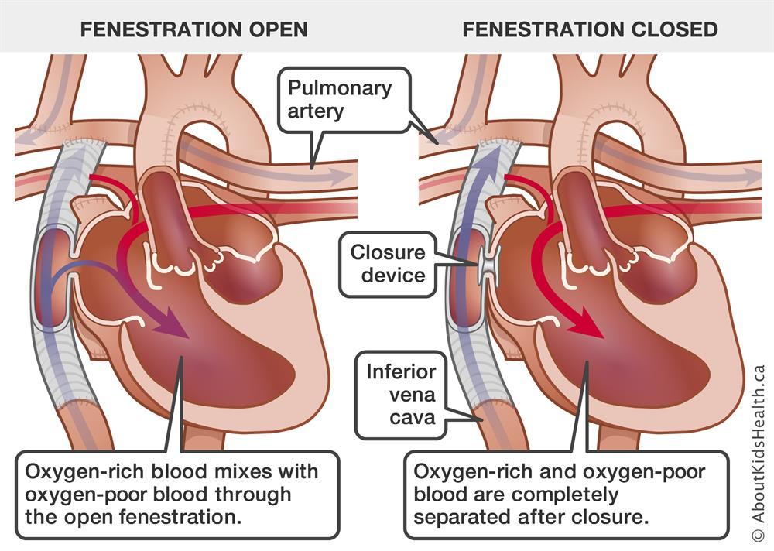

Does having dextrocardia put more stress on my condition with the Fontan?

Individuals who have dextrocardia have their cardiac apex directed to the right (in normal heart structure, it is orientated to the left) – see below diagrams. Having dextrocardia should not put additional stress on a heart with a Fontan circulation.
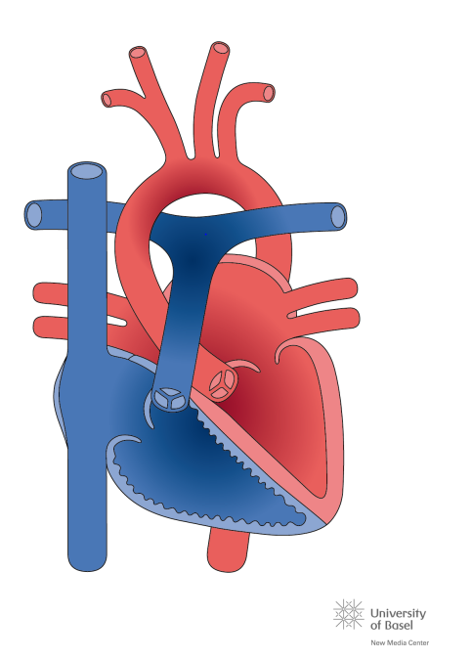 |  | 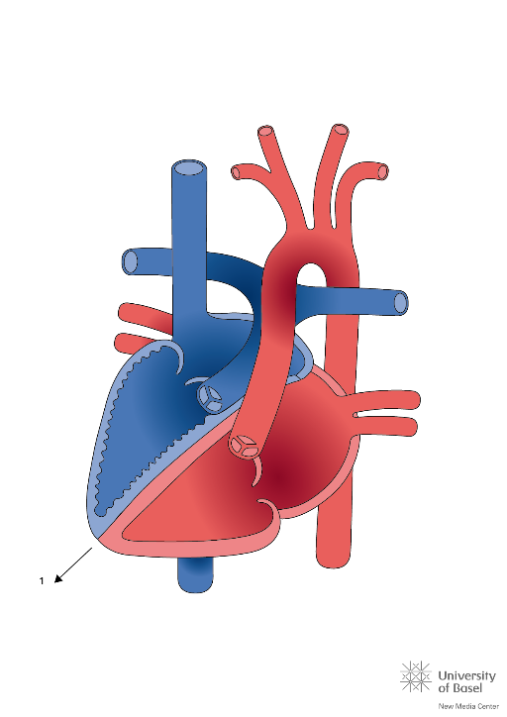
Normal Heart |  | Dextrocardia
Is there an increased risk of liver dysfunction with a midline liver on top of the increased risk from the Fontan circulation in Heterotaxy syndrome?

Because heterotaxy syndrome is a rare condition, we don’t have enough information to appreciate whether there are additional risks to liver function.

Will there be a time when the liver and kidney issues will no longer be a concern? With technology and medical advancements???

We are hopeful that medical advances will reduce (and hopefully eliminate) liver and kidney issues in the future. There are research studies currently in progress studying kidney and liver function in patients with a Fontan circulation.

How can individuals with a Fontan circulation be helpful to medical research?

You can assist in building knowledge about the Fontan circulation and ways to improve outcomes by joining the Fontan registry and participating in available research studies. Please ask the care providers in your province how you can participate.

What is the standard of care to prevent complications?

There isn’t a standard approach to the medical management of a Fontan circulation, you are all somewhat unique!
In general, you will be requested to complete testing (exercise testing, cardiac imaging [CT, MRI, echo], blood work, and liver imaging [CT, MRI, ultrasound, fibroscan] at least once a year. As your Fontan heart function changes, you may be requested to increase the frequency of this testing. You will also need to attend appointments for an examination as part of evaluating your heart’s function – the testing and examination is all part of the ‘active surveillance’ that is important in knowing how you are doing and intervening early to support your heart staying as healthy as possible.

Leading a healthy lifestyle is equally important to prevent complications. For example, alcohol consumption can expedite liver complications that individuals with a Fontan circulation are already at high risk for.

Is the need for liver transplant high in Fontan patients?

When an individual with a Fontan circulation is in need of a heart transplant, their liver function is also considered. If the individual is in heart and liver failure, it may be a consideration to transplant both the heart and the liver at the same time.

In Canada the approach is aiming for a heart transplant alone and we transplant heart and liver in less than 5% of patients. However, this will depend how soon the patient is referred to the transplant unit, the sooner the patient is referred the more likely to be a candidate for a heart alone transplant.

How common are collateral vessels post Fontan?

Collateral vessels form to provide alternative pathways for blood to get to an organ or body region. In a Fontan circulation the high pressure is the venous system triggers the body to build connections (collaterals) from the systemic veins to the pulmonary veins. This pathway has blood ‘detouring’ away from the lungs and will cause an increase in blood that does not have oxygen attached to it.

Collateral vessels are common in a Fontan circulation and this is something that will be monitored by your cardiac team.

Is Dr Rodefeld’s Fontan Blood Pump something that could be used for Fontan patients in Canada?

The Fontan Blood Pump is still in the research and development phase and is not available for use in Canada.

What is the impact of COVID on someone with a Fontan circulation?

Early in the pandemic, cardiac care teams were worried about how the population of individuals with a Fontan circulation would manage with a COVID infection. The multi centre study that was started during the pandemic demonstrated that is wasn’t the structural heart condition that posed a risk, rather it was the physiological state (a classification of heart function). Those individuals who had heart failure and other organs in some degree of failure did less well with COVID than individuals with good heart and organ function.

The mental health effects during the pandemic were significant. The level of anxiety related to the uncertainty and unknowns of the pandemic demonstrated a surge in individuals reporting a deterioration in their mental health. We also witnessed that individuals were more open discussing mental health concerns and making plans and goals to take care of their mental health.

How can you protect your brain health and what to look out for?

You can look after your brain health by leading a healthy lifestyle, maintaining social connections with friends and family, find meaningful work (whether that is paid or volunteer) and reporting any subtle changes to your cognition. Check in with your specialist should you have any neurological concerns and report to the emergency room if you are experiencing any stroke symptoms.

